Manager: Manage Preliminary Map Production
Work Instruction

Purpose

The purpose of the manager role here is to track the Preliminary Map Production activities and the associated QA/QC tasks. The cost, schedule, and percent complete information should be updated regularly. At any time, the Prelim manager may enter or re-enter the projected preliminary date.

Prerequisites

- The Preliminary Map Production process must have been assigned to a specific organization/contractor.
- The final Data Development task associated with this project must have been completed, and the appropriate QA/QC passed.

Navigation
Via Menu Path | Home ➔ Workbench ➔ Work Items  then  Manage Preliminary Map Production
Work Steps
1. Click on: to claim the task you want to perform.
Note: This task does not appear until the last Data Development task has successfully completed QA.
2. Click on: link to enter the task.
3. Click on: arrow to expand and see what information has been entered.
The " FEMA: Mapping Information Platform: Work Items " screen appears:
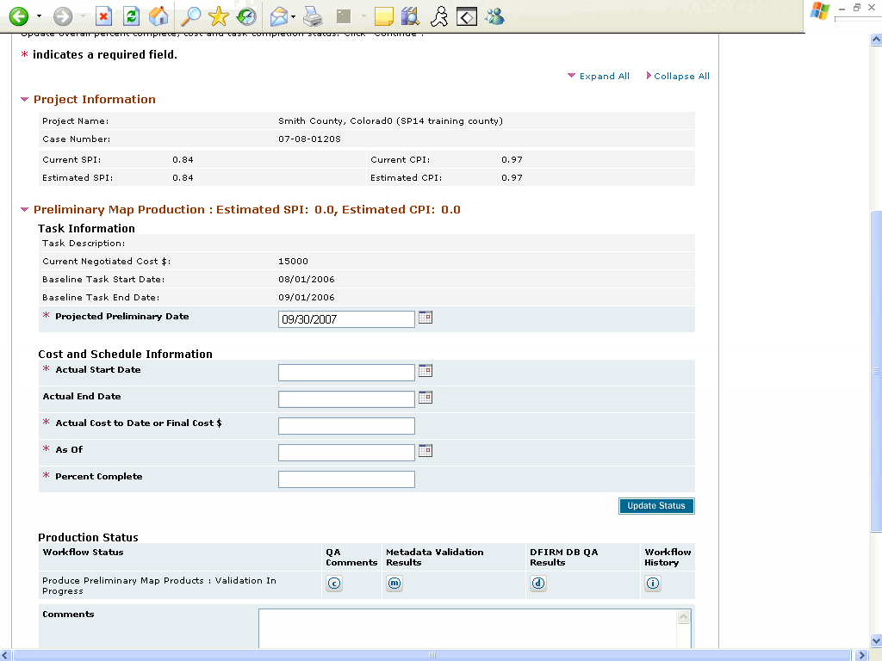
4. Click on and enter Actual Start Date.
Note: It is important that start dates are entered so that EV may calculate correctly.
5. Type 08/09/2006.
6. Click on and enter Actual Cost to Date.
7. Type 10000.
8. Click on: to select the As Of date. In this example, select 08/22/2007.
9. Click on:
Use the arrows to navigate back to August 2007.
10. Click on:
11. Click on: to select August 22 as the As Of date.
12. Click on and enter Percent Complete.
13. Type 80.
The " FEMA: Mapping Information Platform: Work Items " screen appears:
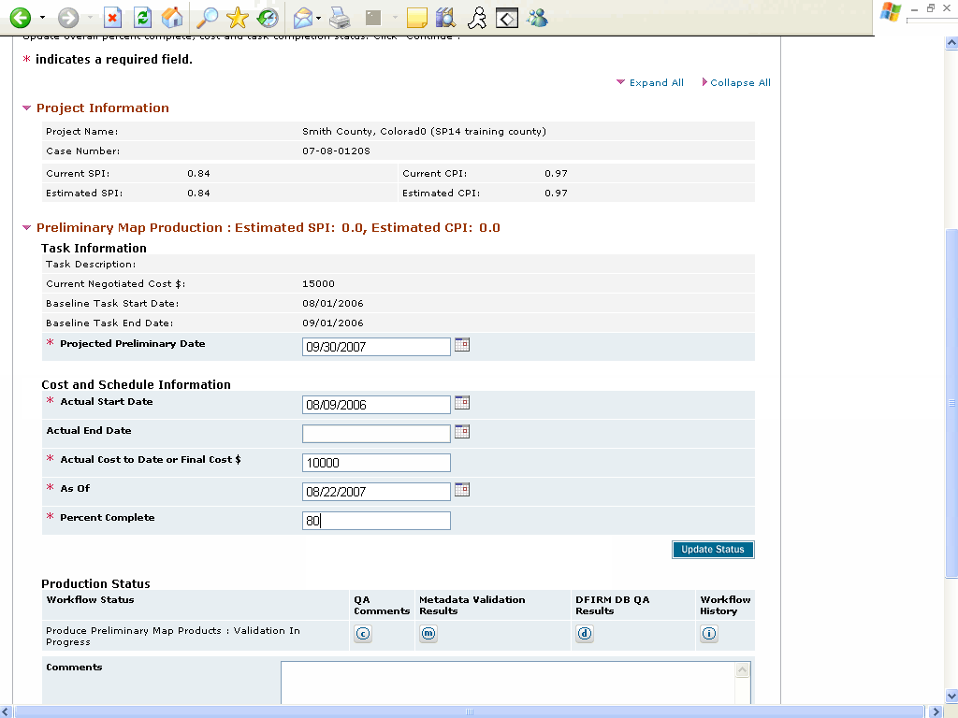
14. Click on and enter Project Preliminary Date.
OOPS! It looks like whoever completed the Draft DFIRM Database entered the wrong Projected Preliminary Date.
Note: This field is critical. This information is used in CIS, as well as by FEMA HQ to report Key Performance Indicator (KPI) progress.
15. Type 9/08/2006.
16. We used the wrong year here too. Click on and enter correct As Of date.
17. Type 08/22/2006.
Note: The Actual End Date field cannot be edited until the producer completes the Distribute Preliminary task. The status of this task can be found in the Production Status box or by clicking the Workflow History icon.
18. Click on: to save this information, and review the impact to EV.
19. Click on: to see who currently has the Produce Preliminary Map Products.
You can use the Workflow History to see who has current tasks claimed, or who completed previous tasks.
20. Click on: after you have seen that you have to track down r8team1idiq to get an update on this task.
21. Click on: link to enter the task.
22. Click on: to see all of the information.
23. Click on: to select the Actual End Date. Select 10/06/2006.
We can see that the Producer has finished the Distribute Preliminary Task, so we need to enter the end date of this task to update our EV information.
24. Click on: to navigate back to 2006.
25. Click on: to navigate back to September.
26. Click on: to select September 8 as the actual end date.
27. Click on and update Final Cost.
28. Type 15000.
29. Click on and update Percent Complete.
30. Type 100.
31. Click on: to select the As Of date. Select 09/08/2006.
32. Click on: to navigate to September.
33. Click on: to select September 8 as the As Of date.
34. Click on: to capture the information and update the EV.
35. Once your final information has been entered, click on: to advance to the Review screen.
Note: The workflow has already advanced into Post-Preliminary. You have 90 days from the completion of the Distribute Preliminary task to update EV information.
36. Click on: to expand all fields.
37. Verify that all information is correct (it is!). Click on: to advance to Complete Task.
38. Click on:
After this is done, any changes or updates must be made by FEMA or the RMC.

Results
Once all Preliminary Production activities have been completed and the submissions have passed QA, the Preliminary maps are distributed to the communities. After that, the post-preliminary processing begins.

